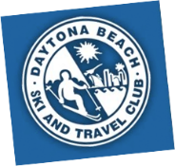
Sun Rail Train Trip to Winter Park
Date: Thursday March 5, 2026 Contact: Linda Kinsella (386) 295-1921
Join us for a scenic train ride from Deland to Winter Park. This itinerary includes train
departure and arrival times, activities in Winter Park, and details about visiting the Morse

Museum.

Departures to Winter Park
Meet at 10:50 AM at Deland Sun Rail Train Station,
2491 Old New York Ave., Deland, FL
- Train Fare: $4.00 each way
- 11:15 AM (arrive Winter Park at12:06 PM)
If you miss the first train, the next train is:
- 12:10 PM (arrive Winter Park at 1:06 PM)

Activities in Winter Park
During your visit to Winter Park, take time to explore local shopping venues, relax at
sidewalk cafes, and discover the renowned Morse Museum.

Morse Museum Information
- Location: 445 N. Park Ave., Winter Park, FL (0.3 mile walk from the train station)
- Hours: 9:30 AM – 4:00 PM … Admission $8.00
- The Morse Museum houses the world’s most comprehensive collection of works by
Louis Comfort Ti any (1848–1933). The collection includes jewelry, pottery,
paintings, art glass, leaded-glass lamps and windows, the artist’s chapel interior
from the 1893 World’s Columbian Exposition in Chicago, and art and architectural
objects from his Long Island country estate, Laurelton Hall. The museum also
features American art pottery and late 19th- and early 20th-century American
paintings, graphics, and decorative art.
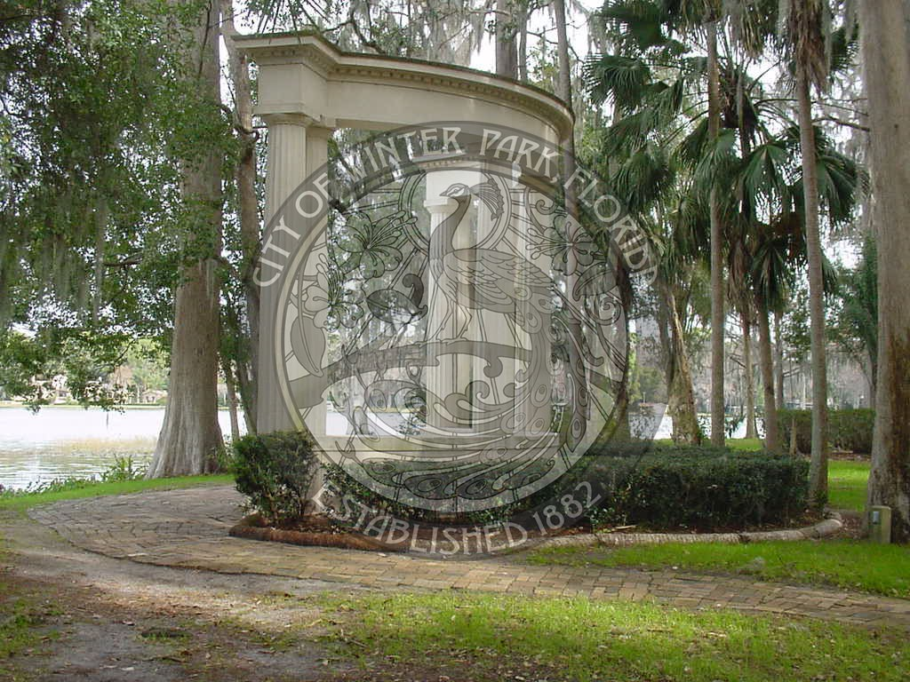
Return to Deland
- Return Fare: $4.00
- Departure Times from Winter Park:
- 3:09 PM (arrive Deland at 4:00 PM)
- 4:09 PM (arrive Deland at 5:00 PM)
- 4:39 PM (arrive Deland at 5:30 PM)

